**COMMENTARY SANDBOX Project Punch List — RELEASE VERSION 2.0**

**MAJOR IMPROVEMENT**

1. Create WSIWYG editing fields for Notes and Vocabulary Custom Fields (have these fields appear by default)
2. Have Notes and Vocabulary Custom Fields appear by default on installation

I did some research and found a promising option here: https://www.farinspace.com/multiple-wordpress-wysiwyg-visual-editors/

**MINOR IMPROVEMENTS**

1. Can the default font for the main text field be changed to Cardo?
2. The default font size in Vocabulary pane should be a little smaller, so that it matches main text.
   1. Note: the font can stay the same (sans serif). I would like the font for the main text to be serif (Cardo if possible) while the fonts for the Table of Contents, Vocabulary, and Notes should be sans serif. The current font for the Table of Contents and Vocabulary = fine.
3. The default font and size in the Notes pane should be changed so that it same as in the Vocabulary Pane
4. Increase default **height** of the header image from 67 to 140.
5. Currently
   1. *While you can crop images to your liking after clicking****Add new image****, your theme recommends a header size of****940 × 67***
6. Change text on default title page (I will provide text)
7. Remove the search, etc. in default footer; make sure the footer, if added has proper CSS styling

Current

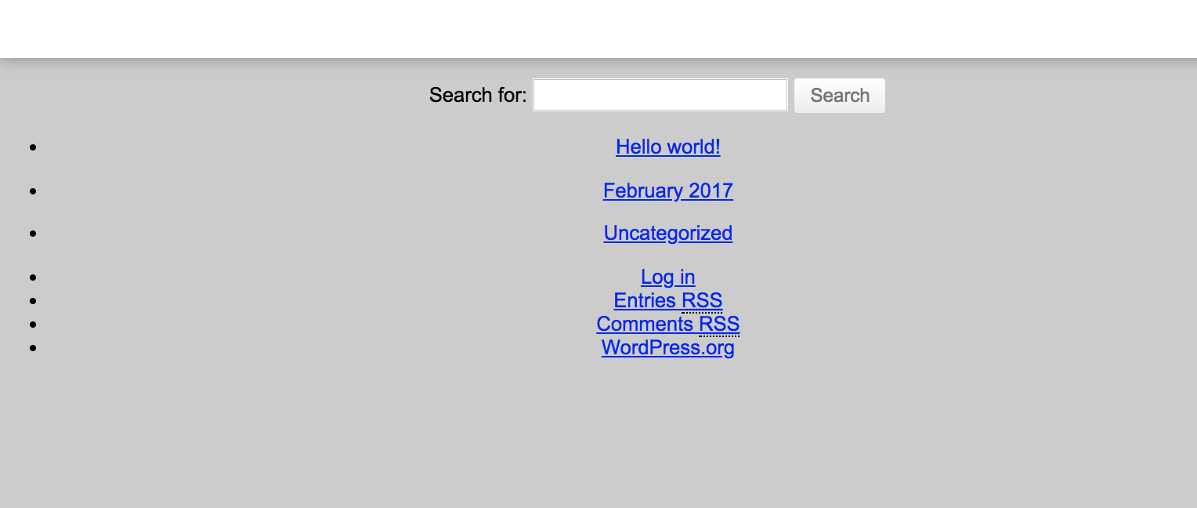

1. Change default widget from CommentPress Footer to Commentary Sandbox Footer (and leave blank, like the navigation top / bottom widgets)

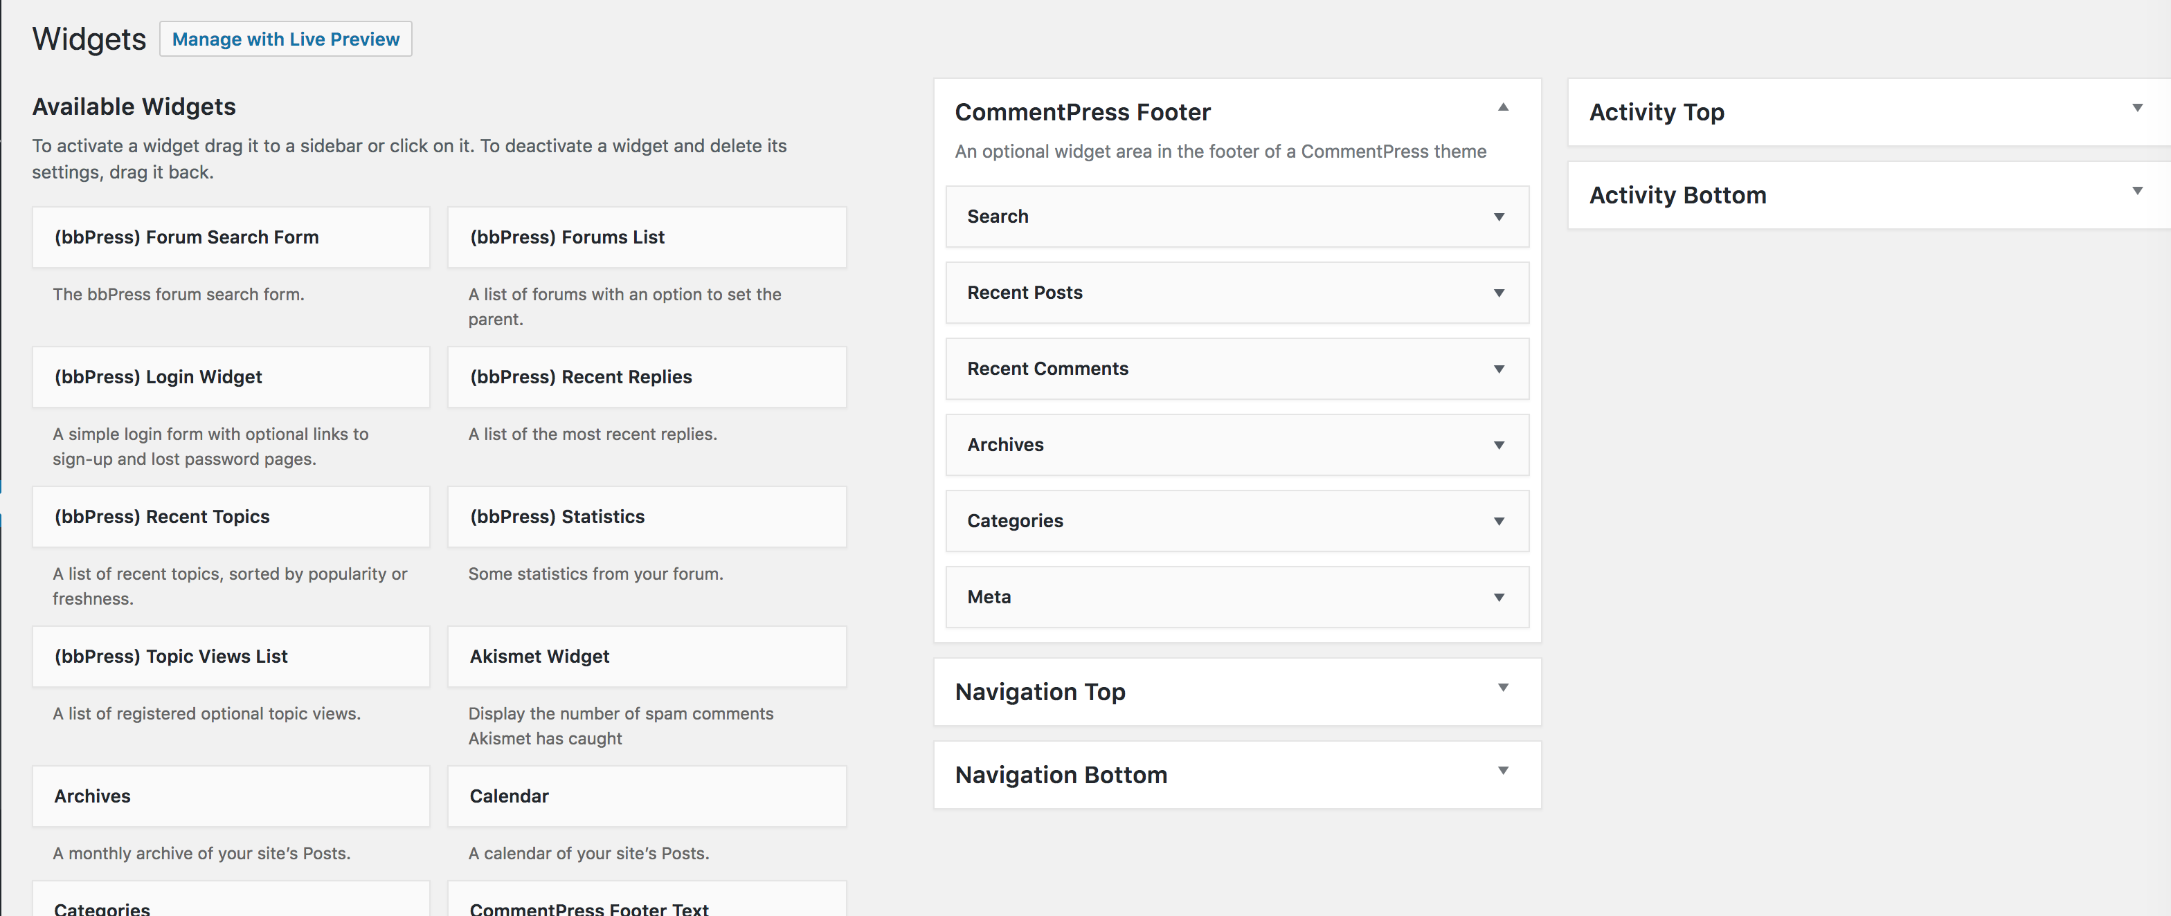

**Question**: Can an option for footer be added to the “Customize” menu? (seen here from “Customize” menu from another site)

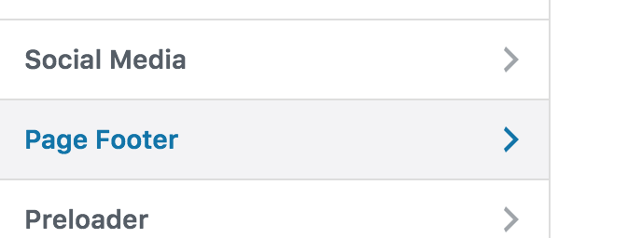

**FINAL**

1. Test for latest version of Wordpress (4.9.8)
2. Test for Wordpress 5.0
3. All changes must be packaged as an installable Wordpress Plugin that can be uploaded to the Wordpress directory. The plugin should named **“Commentary Sandbox 2.0”**